Technology - Devices

5 ციფრული დანადგარი ან ხელსაწყო რომელიც ცხოვრებას ამარტივებს:
1.
2.
3.
4.
5.
Put these 5 inventions into the table below. Describe their main function and how they make life easier for their user. / ჩამოთვალეთ 5 ხელსაწყო (ციფრული). აღწერეთ რას აკეთებს თითოული მათგანი.
Device  ციფრული ხელსაწყო | Function  ფუნქცია | How does it make life easier?  როგორ ამარტივებს ცხოვრებას?

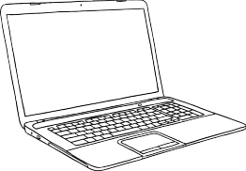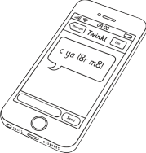

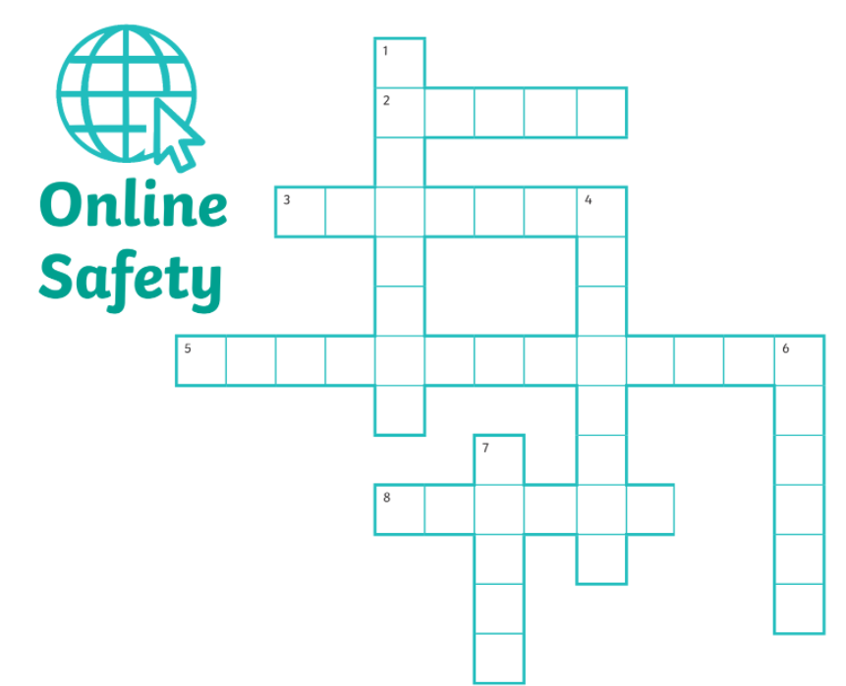

Across |  | Down
2 | Tell an ----------- if you see or read something online that you do not like. | 1 | I must not share my ------------- as I could get hacked.
3 | When communicating online, I must -------------- others. | 4 | Hiding behind a fake profile to be unkind is called----------- .
5 | Bullying online is called -------------- . | 6 | Online ---------------can be good fun with friends.
8 | Only accept --------- requests from people that you know. | 7 | Do not open unknown emails, as they  may contain a -------------.

1-password
2- Adult
3- respect
4-trolling
5-cyberbullying
6-gaming
7-virus
8-friend

